Grazioso Salvare Dashboard

Project Two – CS 340 Client/Server Development

About the Project/Project Title

This project is a full-stack web application dashboard built for Grazioso Salvare, an organization that identifies and trains dogs for search-and-rescue work. The dashboard connects to a MongoDB database containing Austin Animal Center outcomes data and allows users to interactively filter animals by rescue type. The application follows the Model-View-Controller (MVC) pattern: the CRUD Python module created in Project One serves as the Model, the Dash layout serves as the View, and the Dash callbacks serve as the Controller. Users can filter the dataset by Water Rescue, Mountain or Wilderness Rescue, or Disaster/Individual Tracking, and the interactive data table, pie chart, and geolocation map update automatically based on the selected filter.

Required Functionality
The dashboard includes the following required functionality:
- The Grazioso Salvare logo, linked to www.snhu.edu, and a unique identifier displaying the developer's name.
- Interactive filter options (radio buttons) for Water Rescue, Mountain or Wilderness Rescue, Disaster or Individual Tracking, and Reset.
- An interactive data table with sorting, filtering, and pagination that dynamically updates based on the selected rescue type.
- A pie chart showing the breed distribution of the currently filtered data.
- A geolocation chart that displays the location of the selected animal from the data table on a map of Austin, TX.

Screenshots – Proof of Functionality
Figure 1: Starting State – Unfiltered Dashboard with Logo, Unique Identifier, Data Table, Pie Chart, and Map
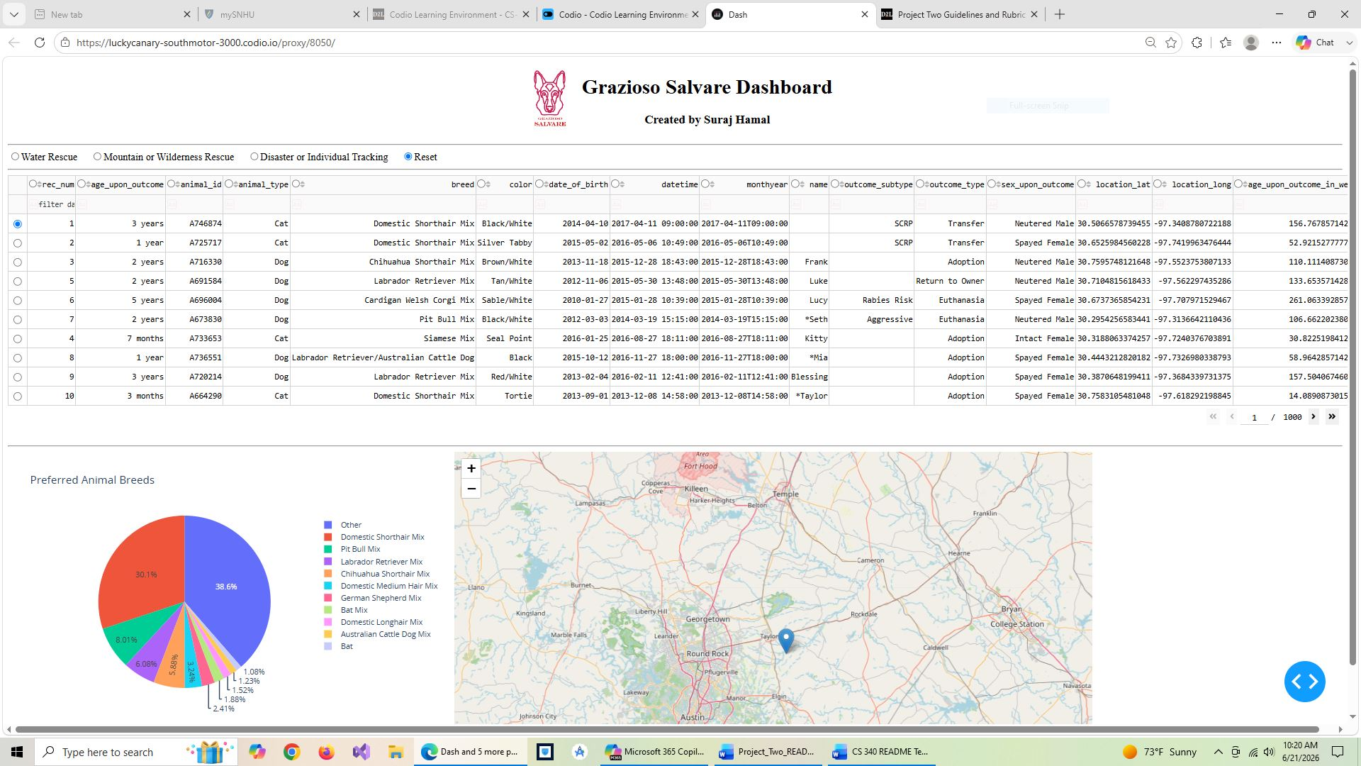

Figure 2: Dashboard Filtered to Display Water Rescue Dogs
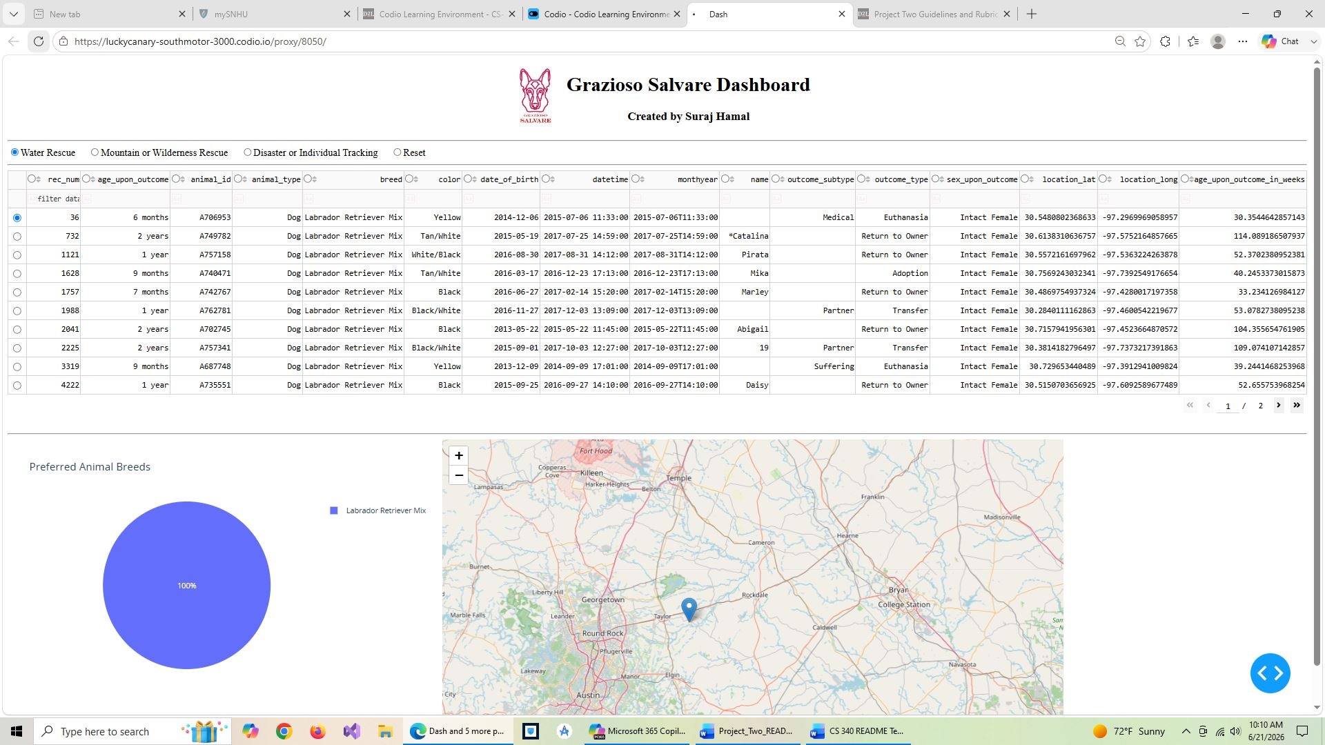

Figure 3: Dashboard Filtered to Display Mountain or Wilderness Rescue Dogs
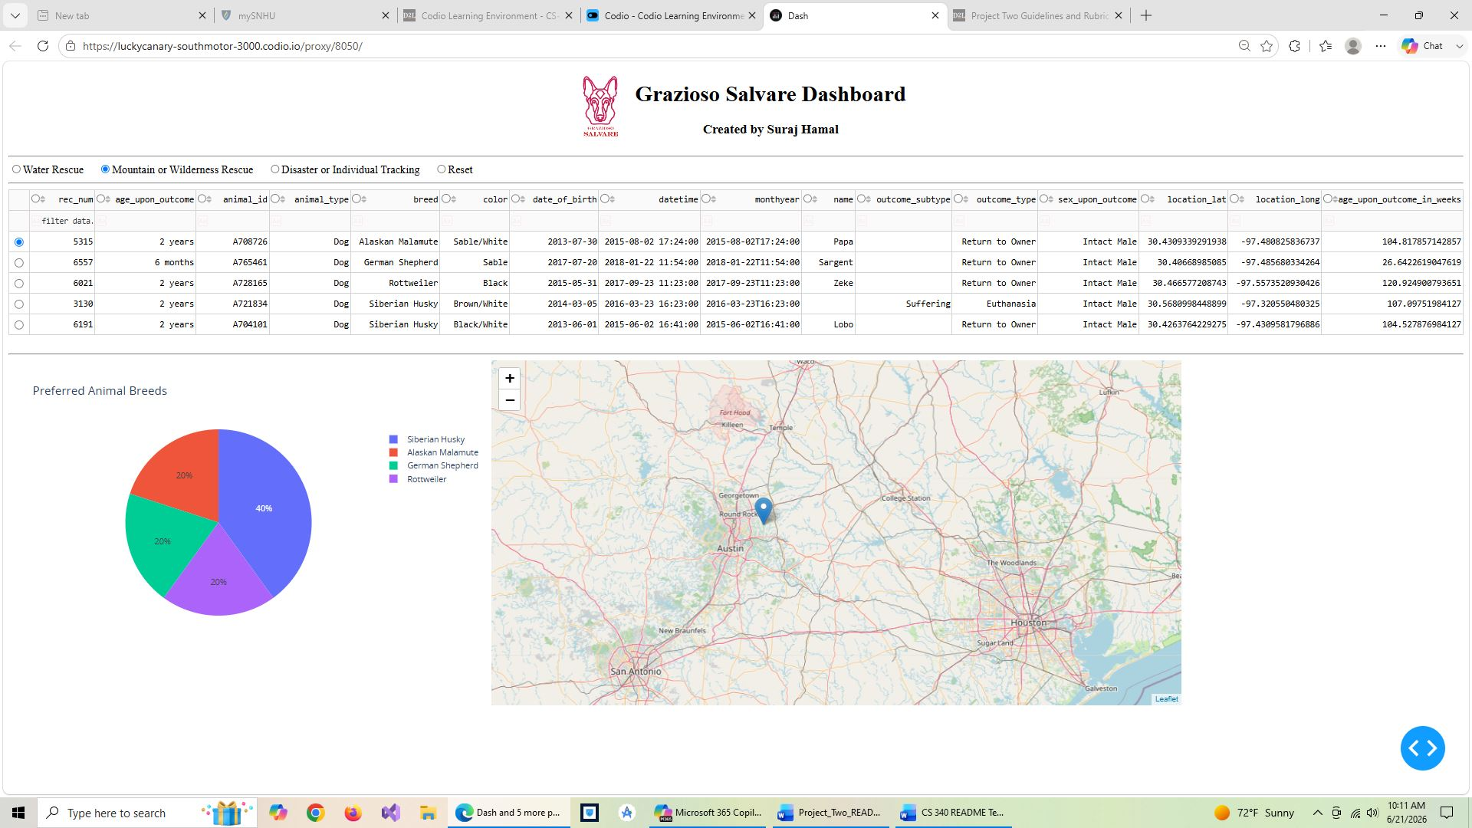

Figure 4: Dashboard Filtered to Display Disaster or Individual Tracking Dogs
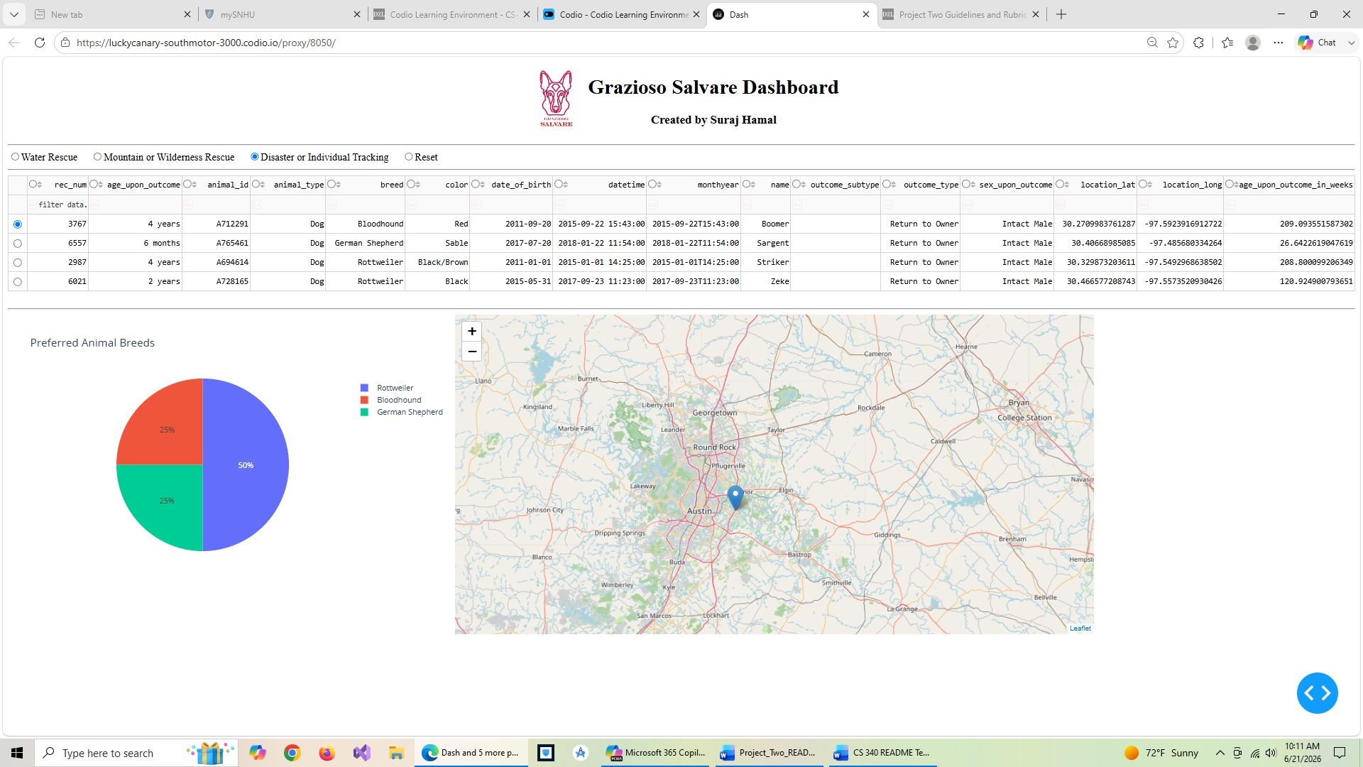

Getting Started

To get a local copy up and running, follow these steps:
- Ensure MongoDB is installed and running on your system (localhost, port 27017).
- Import the AAC dataset into MongoDB using mongoimport with database name "aac" and collection name "animals" using the --type csv and --headerline flags.
- Create the aacuser account in the admin authentication database with readWrite access to the aac database using db.createUser() in the mongo shell.
- Place the CRUD_Python_Module.py file in the same directory as the ProjectTwoDashboard.ipynb file.
- Place the Grazioso Salvare logo image file in the same directory as the dashboard notebook.
- Install the required Python packages: pymongo, pandas, dash, jupyter-dash, dash-leaflet, and plotly.
- Open ProjectTwoDashboard.ipynb in Jupyter Lab and run all cells to launch the dashboard.

Database Setup: The MongoDB instance uses authentication. The aacuser account was created in the admin database with readWrite privileges scoped only to the aac database. This role-based access ensures security by limiting the user to only the data they need.
Module Development: The CRUD module was extended from Project One to include full create, read, update, and delete functionality. The __init__ method was updated to accept username and password as parameters rather than hardcoding them, so credentials can be passed in securely at instantiation. The dashboard uses the read() method to run a "retrieve all" query on load and filtered queries when an interactive option is selected.
Dashboard Development: The dashboard layout was built using Dash components, including a DataTable, RadioItems for filtering, a Plotly Express pie chart, and a Dash Leaflet map. Callback functions connect each filter selection to a MongoDB query, which updates the data table, and a second callback updates the pie chart and map based on the data currently shown in the table.

Installation

The following tools are required:
- MongoDB 7.0: The NoSQL database used to store AAC records. Chosen for its flexible document model that maps naturally to Python dictionaries.
- mongosh: The MongoDB shell used for database setup, user creation, and indexing.
- Python 3: The programming language used to build the CRUD module and the dashboard.
- PyMongo: The official MongoDB driver for Python, used to connect the CRUD module to the database. Install with: pip install pymongo
- Pandas: Used to convert MongoDB query results into DataFrames for the data table and charts. Install with: pip install pandas
- Dash and JupyterDash: The web application framework used to build the interactive dashboard inside Jupyter. Install with: pip install dash jupyter-dash
- Dash Leaflet: Used to render the interactive geolocation map. Install with: pip install dash-leaflet
- Plotly Express: Used to generate the pie chart. Installed automatically as a Dash dependency.
- Jupyter Lab: Used to run and test the dashboard interactively and capture screenshots of execution results.

Usage

Code Example

Tests

The CRUD module was tested in Jupyter Lab using the ProjectOneTestScript.ipynb notebook, which exercises all four CRUD operations: create(), read(), update(), and delete(). The dashboard itself was tested by running ProjectTwoDashboard.ipynb and verifying that each of the four filter options (Water Rescue, Mountain Rescue, Disaster Rescue, and Reset) correctly updates the data table, pie chart, and geolocation map.

Contact
Your name: Suraj Hamal

